Renju lesson on February 28, 2002

Hello everyone! Welcome to Online Renju Class. Today is the last lesson about d13. And today is the last lesson of playsite, too. The new classroom is already complete. My wish is to open it right after today’s lesson. We can make the test today, to see if it can bear 20-30 people without problems.

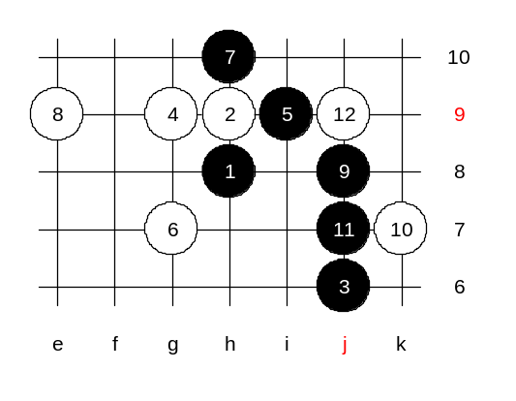
About d13 now. How many of you found the win in advanced homework?
Black’s 9-j8 is very logical. And then? Most of you suggest j7, lets try it out.

Seems nobody found win. Ok, then we stop here, and name it unclear.

I did not search myself too deeply because the variant is not so urgent. According to current opening rules, black needs two 5th moves to survive. Right? Therefore, all we need to do is to kill every alternative 5th move and then white wins.
We already proved white win after 5-f9. Where else can black play? Ok, we check 5-g8 now.
Do you prefer white’s 6-f9 or 6-f8? Ok you chose f9.
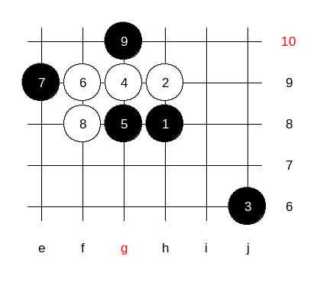

If you cannot find white win here, then maybe 6-f9 isn’t so good? It is too troublesome to search here, therefore I recommend the soft style with 6-f8.

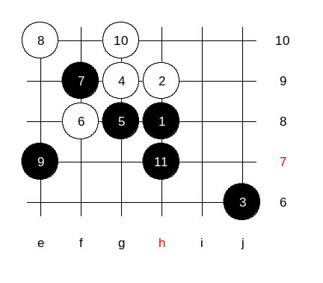

Careless 10th move caused white lots of trouble.

I have a very good idea!
This 5th move will be your advanced homework!

